EQ3 FURNITURE AND ACCESSORIES

**Founded in 2001, EQ3 is a Canadian retailer and manufacturer committed to quality craftsmanship and design. EQ3 promotes original design, domestic manufacturing, and a unique Canadian perspective on modern home furnishings and products. EQ3 was established in Winnipeg under the direction of Peter Tielmann. After moving to Canada from Germany, Peter began working for Palliser Furniture and recognized the need for a modern Canadian furniture retail alternative in North America — one that caters to a design-oriented client looking for quality furniture that will stand the test of time. While at first designed to be sold through other retailers, after rapid success the concept of a franchise developed and free-standing EQ3 stores began opening across the country. Realizing that in order to develop a strong brand that speaks to the passion for modern design and innovative furniture, Tielmann and EQ3 decided to buy back those Canadian franchises and work toward creating a concept store from which to base the experience, vision, and language EQ3 represents. EQ3 has since grown to become a vertically integrated chain of retail stores that champions innovation and quality furniture design for everyday life and for every home, no matter the size. Alongside our exclusive EQ3 product line, we have also expanded our retail offering with EQ3+, a line that partners with modern design institutions and brands like Herman Miller, Vitra, and Marimekko to provide access to design classics from Charles and Ray Eames to contemporary innovations by the Bouroullec brothers. This curated line of brands proves the value and timelessness of authentic design and showcases how our line of new classics can fit beside these storied pieces.**

**This company provides products as Wholesale price.**

Presented by:

**Student Name 1: Gaurav Manchanda (C0752979)**

**Student Name 2: Naveen Chawla (C0753964)**

**Student Name 3: Harjinder Singh (C0751685)**

**Student Name 4: Harman Singh (C0751548)**

**Student Name 5: Narinder Pal Singh (C0751163)**

EQ3 FURNITURE PRODUCTS

* Couch
* Dining Table
* Modern Lamps
* Modern chandeliers
* King Size Bed
* Queen Size Bed
* Bar chairs
* Lights
* Office Furniture

CUSTOMER SALES INVOICE

Customer Mobile Number: 4372194774

Bill Number: 3

Bill Date: 2019-07-20

Product Code: 1002

Quantity: 3

Grand Total: 3000

Shipping ID: 3

Shipping Address: Gaurav Manchanda, 455 King St. Toronto, ON, M9B6LB

Delivery Date: 2019-07-25

Dispatch Date: 2019-07-30

Delivery Status: 1 [Status 1 Means Delivered Status 0 Means Not Delivered]

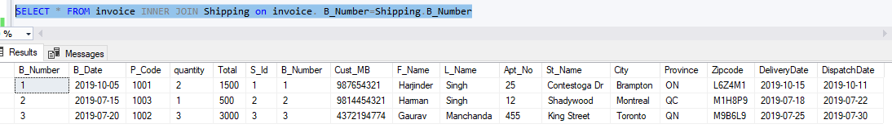

ENTITY & ATTRIBUTES

**ENTITY: COMPANY**

**Attribute:**

* **C_ID(PK)**
* **C_Name**

**ENTITY: PRODUCT**

**Attribute:**

* **P_Code(PK)**
* **P_Name**
* **C_ID(FK)**
* **P_Price**
* **P_Weight**
* **P_Color**
* **P_Size**

**ENTITY: INVOICE**

**Attribute:**

* **B_Number(PK)**
* **B_Date**
* **P_Code(FK)**
* **Quantity**
* **Total**

**ENTITY: IVENTORY**

**Attribute:**

* **ID(PK)**
* **Product_id(FK)**
* **Quantity**

**ENTITY: SHIPPING**

**Attribute:**

* **S_ID(PK)**
* **B_Number(FK)**
* **Cust_MB**
* **F_Name**
* **L_Name**
* **Apt_No**
* **St_Name**
* **City**
* **Province**
* **Zipcode**
* **Delivery_Date**
* **Dispatched_Date**

**ENTITY: DELIVERY**

**Attribute:**

* **S_ID(FK)**
* **Delivery_Status(FK)**

CONCEPTUAL MODEL

1. **ENTITIES**

* **COMPANY**
* **PRODUCT**
* **INVOICE**
* **SHIPPING**
* **DELIVERY**
* **INVENTORY**

1. **ATTRIBUTES**

**COMPANY**

* **C_ID**
* **C_NAME**

**PRODUCT**

* **P_CODE**
* **P_NAME**
* **P_PRICE**
* **C_ID**
* **P_WEIGHT**
* **P_SIZE**
* **P_COLOR**

**INVOICE**

* **B_NUMBER**
* **B_DATE**
* **P_CODE**
* **TOTAL**

**IVENTORY**

* **ID(PK)**
* **Product_id(FK)**
* **Quantity**

**SHIPPING**

* **S_ID**
* **B_NUMBER**
* **Cust_MB**
* **F_Name**
* **L_Name**
* **Apt_No**
* **St_Name**
* **City**
* **Province**
* **Zipcode**
* **DISPATCH_DATE**
* **DELIVERY_DATE**

**DELIVERY**

* **S_ID**
* **DELIVERY_STATUS**

**ER DIAGRAM**

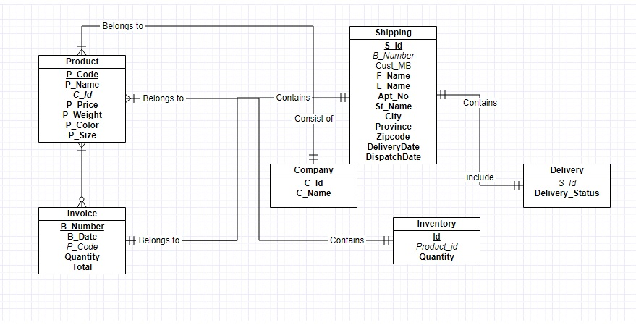

**ENTITY & ATTRIBUTE IDENTIFICATION**

Entity Names: COMPANY, PRODUCT, INVOICE, SHIPPING, DELIVERY

COMPANY TABLE

|  |  |  |  |
| --- | --- | --- | --- |
| Attribute | Data Type | Constraint | Details |
| C_ID | Int | Primary Key | Company ID |
| C_Name | varchar(50) | Not null | Company Name |

PRODUCT TABLE

|  |  |  |  |
| --- | --- | --- | --- |
| Attribute | Data Type | Constraint | Details |
| P_Code | Int | Primary Key | Product Code |
| P_Name | varchar(50) | Not null | Product Name |
| C_ID | Int | Not null | Company ID |
| P_Price | Numeric(5,0) | Not null | Product Price |
| P_Weight | varchar(20) |  | Product Weight |
| P_Color | varchar(50) |  | Product Color |
| P_Size | varchar(50) |  | Product Size |

INVOICE TABLE

|  |  |  |  |
| --- | --- | --- | --- |
| Attribute | Data Type | Constraint | Details |
| B_Number | Int | Primary Key | Bill Number |
| B_Date | Date | Not null | Bill Date |
| P_Code | Int | Not null | Product Code |
| Quantity | Int | Not null | Quantity of Products |
| Total | Numeric(5,0) | Not null | Total Bill |

IVENTORY TABLE

|  |  |  |  |
| --- | --- | --- | --- |
| Attribute | Data Type | Constraint | Details |
| ID | Int | Primary Key | Inventory ID |
| Ptoduct_id | Int | Foreign Key | Product ID |
| Quantity | Int |  | Quantity of Products |

SHIPPING TABLE

|  |  |  |  |
| --- | --- | --- | --- |
| Attribute | Data Type | Constraint | Details |
| S_Id | Int | Primary Key | Shipping ID |
| B_Number | Int | Foreign Key | Bill Number |
| Cust_MB | Varchar(15) | Not null | Customer Mobile Number |
| F_Name | Varchar(20) | Not null | First Name |
| L_Name | Varchar(20) |  | Last Name |
| Apt_No | Int |  | Apartment Number |
| St_Name | Varchar(30) |  | Street Name |
| City | Varchar(20) |  | City Name |
| Province | Varchar(2) |  | Province/State |
| Zipcode | Varchar(6) |  | Zipcode |
| DeliveryDate | Date |  | Delivery Date |
| DispatchDate | Date |  | Dispatched Date |

DELIVERY TABLE

|  |  |  |  |
| --- | --- | --- | --- |
| Attribute | Data Type | Constraint | Details |
| S_ID | Int | Foreign Key | Shipping ID |
| Status | Int | Not null | Delivery Status of Product |

LOGICAL MODEL

**NORMALIZATION & RELATIONAL SCHEMA**

1. **DELIVERY (S_ID** , **DELIVERY_STATUS)**

|  |  |
| --- | --- |
| **S_ID** | **DELIVERY STATUS** |
| **1** | **0** |
| **2** | **1** |
| **3** | **1** |

**NOTE: Status 0 Means Not Delivered Status 1 Means Order Delivered**

1. **SHIPPING (S_ID, *B_NUM ,*** Cust_MB ***,*** F_Name,L_Name,Apt_No,St_Name,City,Province,Zipcode, DELIVERY_DATE, DISPATCH_DATE)

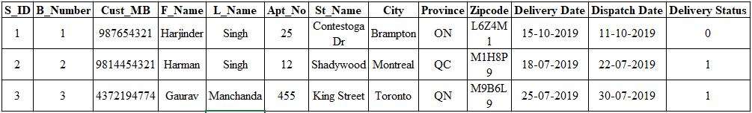

**3. INVOICE (** **B_NUMBER**, B_DATE,***P_CODE***, Quantity, TOTAL**)**

|  |  |  |  |  |
| --- | --- | --- | --- | --- |
| **B_NUMBER** | **B_DATE** | **P_CODE** | **QUANTITY** | **TOTAL** |
| 1 | 05-10-2019 | 1001 | 2 | 1500 |
| 2 | 15-07-2019 | 1003 | 1 | 500 |
| 3 | 20-07-2019 | 1002 | 3 | 3000 |

**4. INVOICE (** **B_NUMBER**, B_DATE,***P_CODE***, Quantity, TOTAL**)**

|  |  |  |  |  |
| --- | --- | --- | --- | --- |
| **B_NUMBER** | **B_DATE** | **P_CODE** | **QUANTITY** | **TOTAL** |
| 1 | 05-10-2019 | 1001 | 2 | 1500 |
| 2 | 15-07-2019 | 1003 | 1 | 500 |
| 3 | 20-07-2019 | 1002 | 3 | 3000 |

1. **PRODUCT(P_CODE**,P_NAME,RATE,P_WEIGHT,COLOR,SIZE, ***C_ID*)**

|  |  |  |  |  |  |  |
| --- | --- | --- | --- | --- | --- | --- |
| **P_CODE** | **P_NAME** | **C_ID** | **P_Price** | **P_Weight** | **P_Color** | **P_Size** |
| 1001 | Queens Bed | 1 | 750 | 20 KG | Black and White | 6 by 6 |
| 1002 | King Bed | 1 | 1000 | 25 KG | Brown and Black | 7 by 7 |
| 1003 | Bar Chair | 2 | 500 | 10 KG | Black | Medium |

1. **COMPANY(C_ID,** NAME)

|  |  |
| --- | --- |
| **C_ID** | **NAME** |
| 1 | EQ3 FURNITURE |
| 2 | EQ3 FURNITURE 2 |

PHYSICAL MODEL

create database EQ3_OnPrem

use EQ3_OnPrem

create table Company(

C_Id int primary key,

C_Name varchar(50) not null UNIQUE);

create table Product(

P_Code int primary key CONSTRAINT CK_VAL CHECK(P_Code>1000),

P_Name varchar(50) not null,

C_ID int foreign key(C_ID) references Company(C_ID),

P_Price numeric(5,0),

P_Weight varchar(20),

P_Color varchar(50),

P_Size varchar(50));

create table invoice(

B_Number int Primary key,

B_Date date,

P_Code int foreign key(P_Code) references Product (P_Code),

quantity int,

Total numeric(5,0));

create table Shipping(

S_Id int primary key,

B_Number int foreign key(B_Number) references invoice (B_Number),

Cust_MB varchar(15),

F_Name varchar(20) not null,

L_Name varchar(20),

Apt_No int,

St_Name varchar(30),

City varchar(20),

Province varchar(2),

Zipcode varchar(6),

DeliveryDate date,

DispatchDate date);

create table Delivery(

S_Id int foreign key(S_ID) references shipping (S_ID) Unique,

Delivery_Status int);

create table inventory(

id int primary key,

product_id int FOREIGN KEY REFERENCES product(P_code),

quantity int default 0

);

insert into Company(C_Id,C_Name)

Values(1,'EQ3 Furnitures');

insert into Company(C_Id,C_Name)

Values(2,'EQ3 Furnitures1');

insert into Product(P_Code,P_Name,C_ID,P_Price,P_Weight,P_Color,P_Size)

values(1001,'Queens Bed',1,750,'20 KG','Black and White','6 by 6');

insert into Product(P_Code,P_Name,C_ID,P_Price,P_Weight,P_Color,P_Size)

values(1002,'King Bed',1,1000,'25 KG','Brown and Black','7 by 7');

insert into Product(P_Code,P_Name,C_ID,P_Price,P_Weight,P_Color,P_Size)

values(1003,'Bar Chair',2,500,'10 KG','Black','Medium');

insert into inventory(id, product_id, quantity)

values (1, 1001, 10);

insert into inventory(id, product_id, quantity)

values (2, 1002, 10);

insert into inventory(id, product_id, quantity)

values (3, 1003, 10);

insert into invoice(B_Number,B_Date,P_Code,quantity,Total)

values(1,'2019-10-05',1001,2,1500);

insert into invoice(B_Number,B_Date,P_Code,quantity,Total)

values(2,'2019-07-15',1003,1,500);

insert into invoice(B_Number,B_Date,P_Code,quantity,Total)

values(3,'2019-07-20',1002,3,3000);

Select * from Shipping

insert into Shipping(S_Id,B_Number,Cust_MB,F_Name,L_Name,Apt_No,St_Name,City,Province,Zipcode,DeliveryDate,DispatchDate)

values(1,1,987654321,'Harjinder','Singh',25,'Contestoga Dr', 'Brampton','ON','L6Z4M1','2019-10-15','2019-10-11');

insert into Shipping(S_Id,B_Number,Cust_MB,F_Name,L_Name,Apt_No,St_Name,City,Province,Zipcode,DeliveryDate,DispatchDate)

values(2,2,9814454321,'Harman','Singh',12,'Shadywood', 'Montreal','QC','M1H8P9','2019-07-18','2019-07-22');

insert into Shipping(S_Id,B_Number,Cust_MB,F_Name,L_Name,Apt_No,St_Name,City,Province,Zipcode,DeliveryDate,DispatchDate)

values(3,3,4372194774,'Gaurav','Manchanda',455,'King Street', 'Toronto','QN','M9B6L9','2019-07-25','2019-07-30');

insert into Delivery(S_Id,Delivery_Status)

values(1,0);

insert into Delivery(S_Id,Delivery_Status)

values(2,1);

insert into Delivery(S_Id,Delivery_Status)

values(3,1);

select * from Company

select * from Product

select * from invoice

select * from Shipping

select * from Delivery

select * from inventory

SELECT * FROM invoice INNER JOIN Shipping on invoice. B_Number=Shipping.B_Number

CREATE TRIGGER tr_decrease_inventory

ON invoice

AFTER insert

AS

BEGIN

SET NOCOUNT ON;

Declare @product_id int

declare @sell_qty int

set @product_id = (Select p_code from inserted)

set @sell_qty = (select quantity from inserted)

update inventory

set quantity = quantity-@sell_qty

where product_id = @product_id

END

GO

DATABASE CONSTRAINT

**PRIMARY KEY**

create table Company(C_Id int primary key,C_Name varchar(50) UNIQUE);

**FOREIGN KEY**

ALTER TABLE Delivery ADD FOREIGN KEY (S_ID) REFERENCES Shipping(S_Id);

**UNIQUE KEY**

create table Company(C_Id int primary key,C_Name varchar(50) UNIQUE);

**PRODUCT CONTRAINT**

create table Product(P_Code int primary key CONSTRAINT CK_VAL CHECK(P_Code>1000)

**NOT NULL CONTRAINT**

create table Product(P_Code int primary key CONSTRAINT CK_VAL CHECK(P_Code>1000),P_Name varchar(50) not null,

create table Shipping(

F_Name varchar(20) not null,

Creating Trigger

CREATE TRIGGER tr_decrease_inventory

ON invoice

AFTER insert

AS

BEGIN

SET NOCOUNT ON;

Declare @product_id int

declare @sell_qty int

set @product_id = (Select p_code from inserted)

set @sell_qty = (select quantity from inserted)

update inventory

set quantity = quantity-@sell_qty

where product_id = @product_id

END

GO

**OUTPUTS OF TABLES**

select * from Company

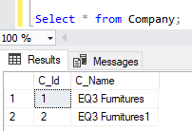

select * from Product

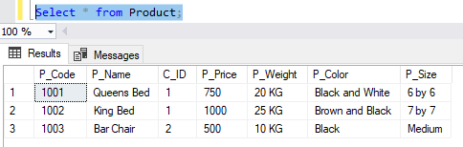

select * from invoice

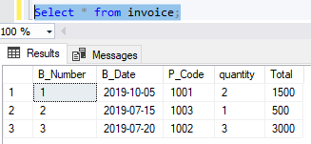

select * from inventory

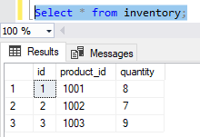

select * from Shipping

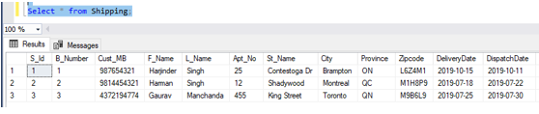

select * from Delivery

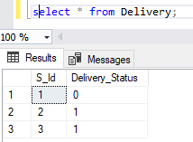

SELECT * FROM invoice INNER JOIN Shipping on invoice. B_Number=Shipping.B_Number

**CONSTRAINT TESTING**

**1) Primary Key**

insert into Product(P_Code,P_Name,C_ID, P_Price,P_Weight,P_Color,P_Size)

values(1001,'Queens Bed',1,750,'20 KG','Black and White','6 by 6');

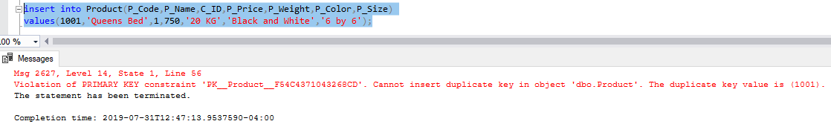

**2) Foreign Key**

insert into Delivery(Ship_Id,Delivery_Status)values(5,0);

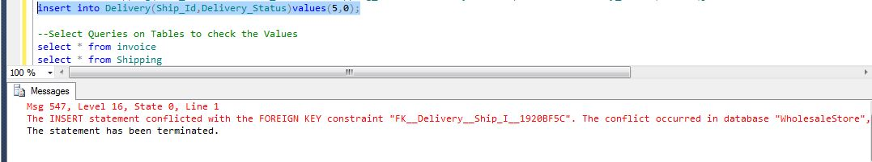

**3) Unique Key**

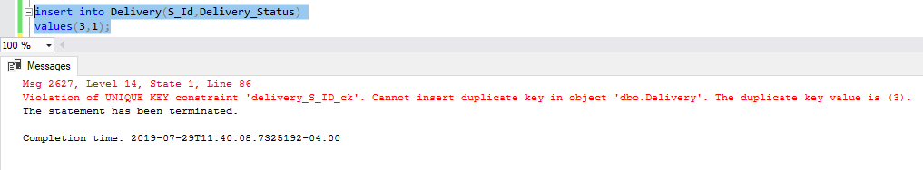

**4) Check Constraint**

Product Number Should be greater than 1000

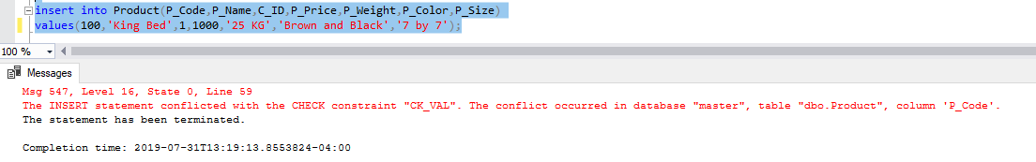

**Cloud Setup(Azure)**

**Server Created ;- CBD**

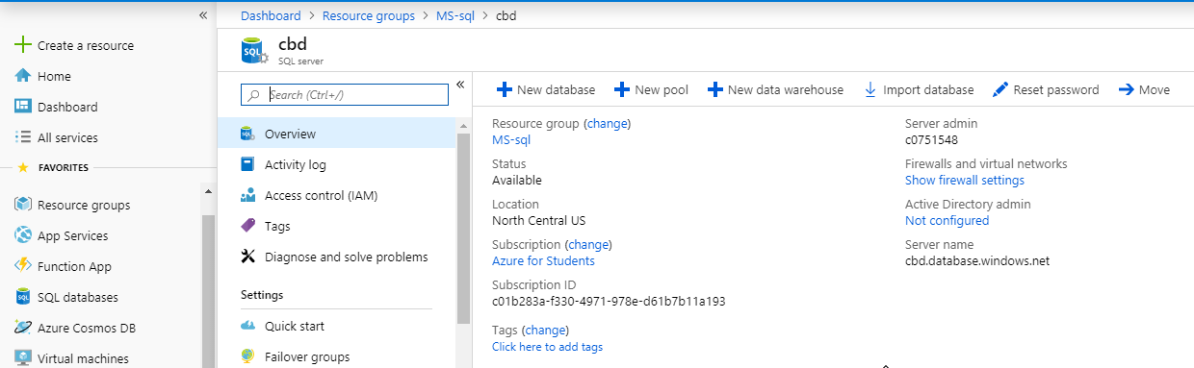

Resource Group – MS-sql

Server Credentials – c0751548/**********

**Making Connection to Server** –

1. Adding Client IP to Firewall

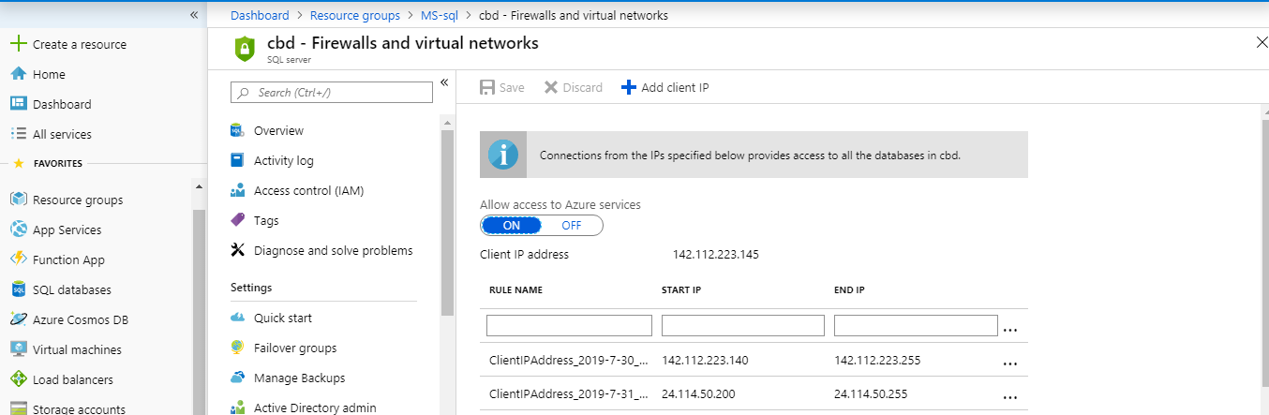

1. Connecting via SQL management Studio on Local Machine

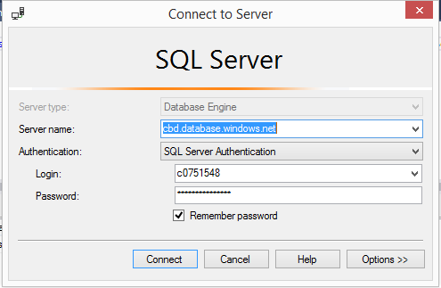

**Database Migration**

**Taking Export of Local Server(EQ3_OnPrem)**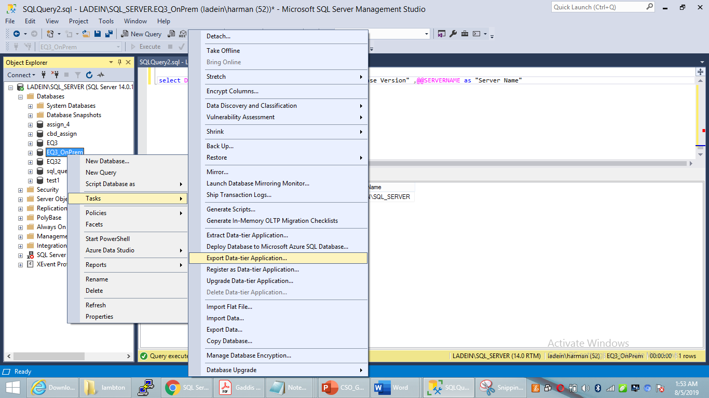

**Importing Logical Backup to Azure Cloud –**

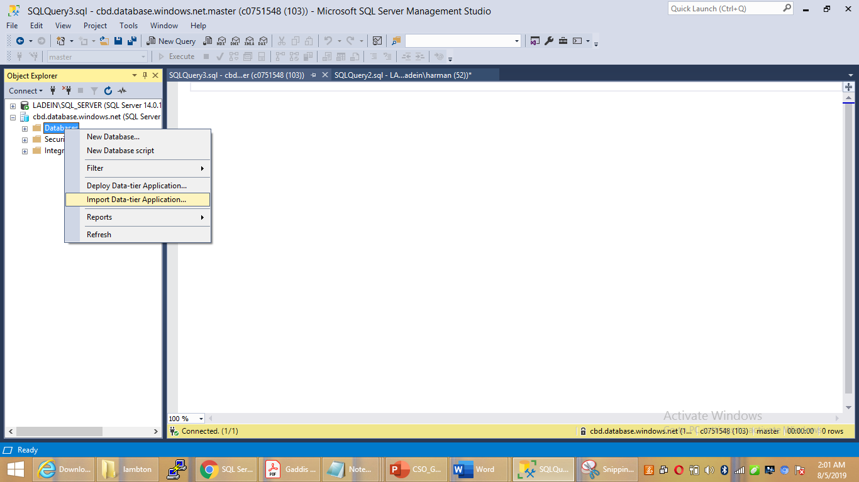

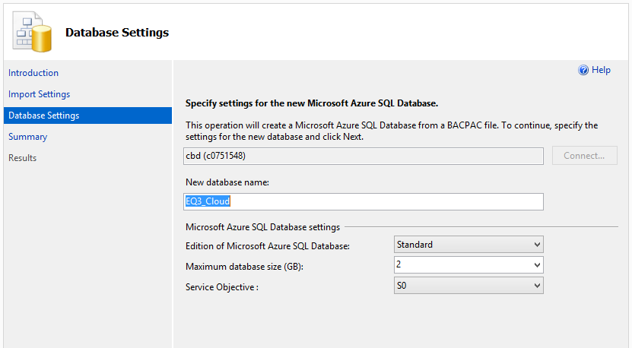

**Validation**

**Verifying DATA after Migration**

**ON Premises Database :**

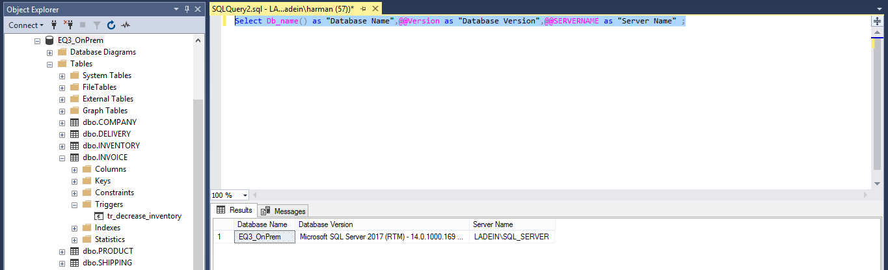

**Cloud Database –**

